Assignment 10
Student Name and ID: Adilzhan Shaikhyslamov 22B030610
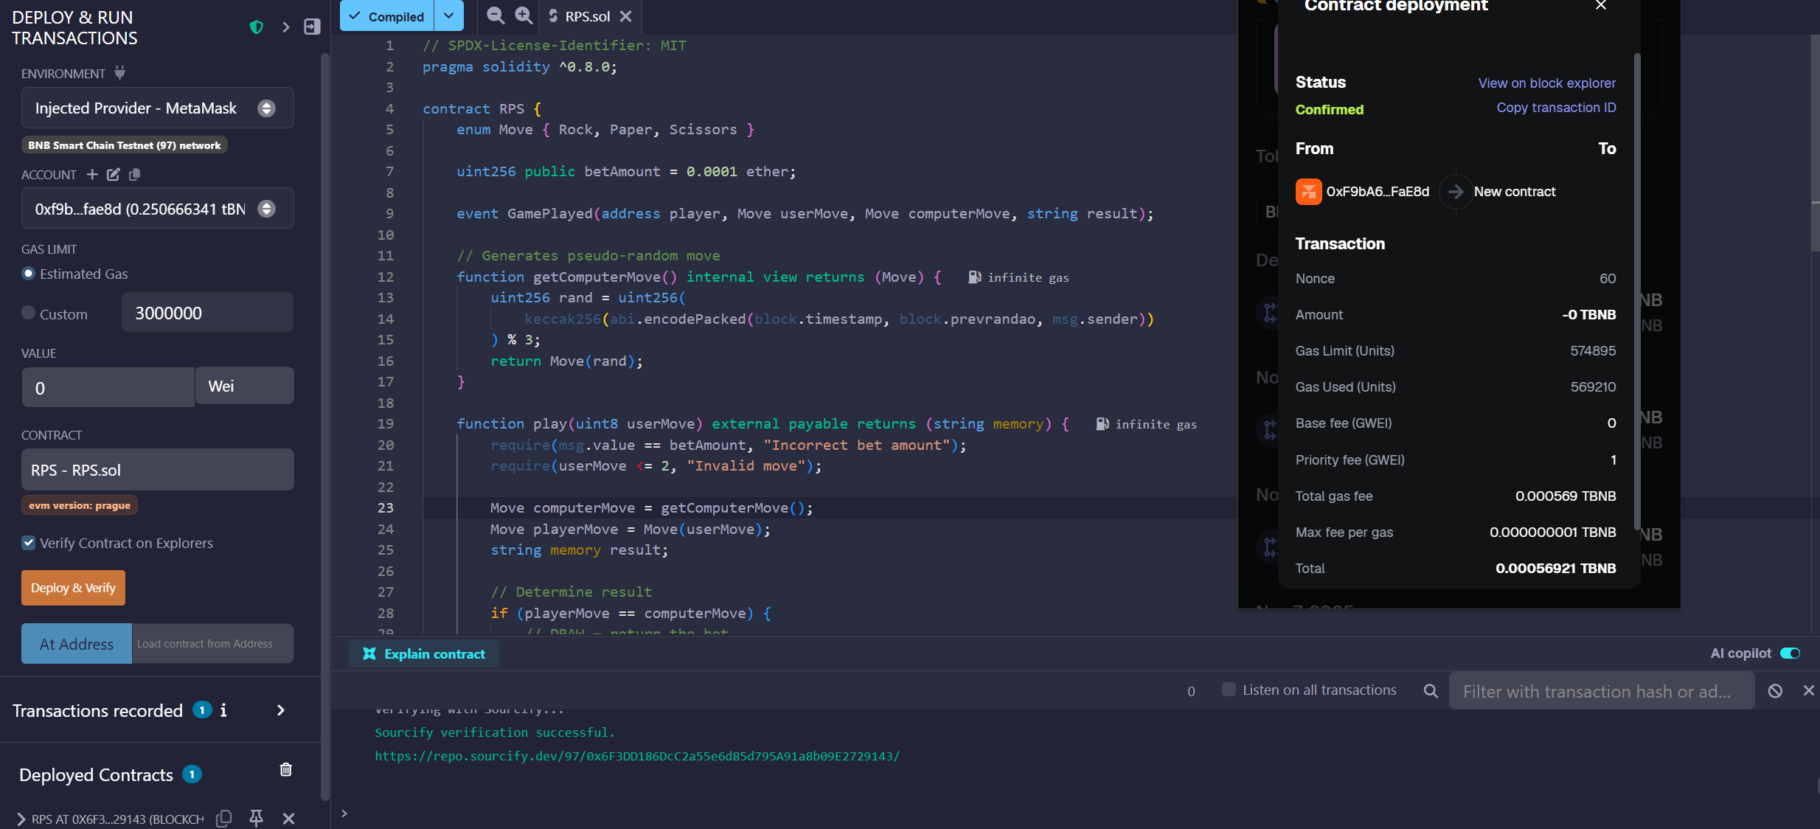
Contract Address: 0x6F3DD186DcC2a55e6d85d795A91a8b09E2729143
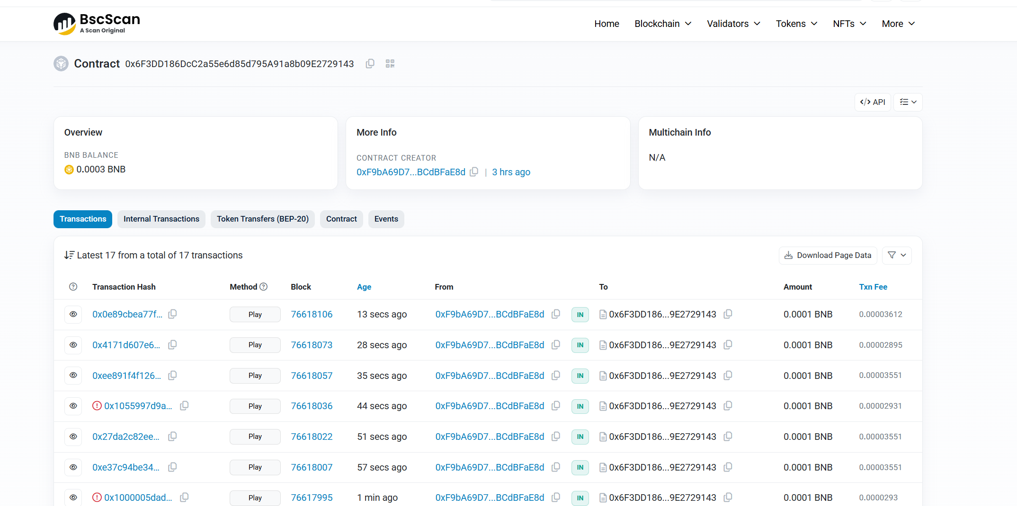
There are evidence of the work of the game
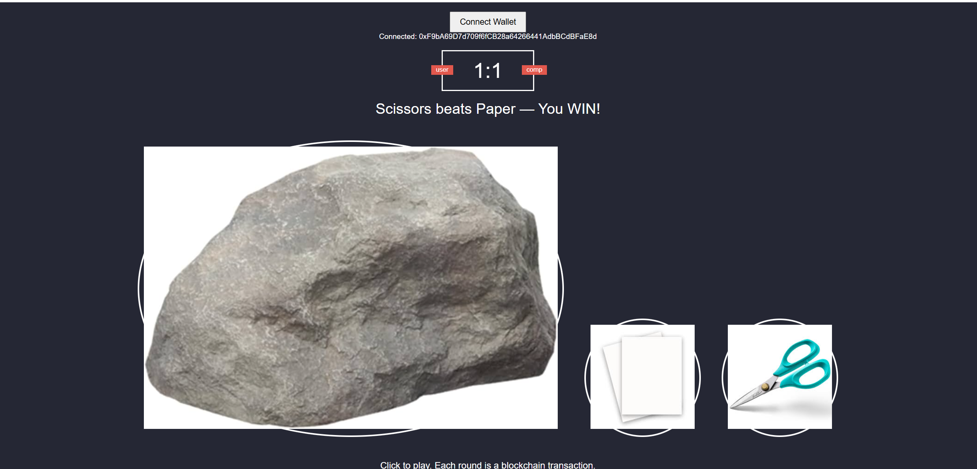
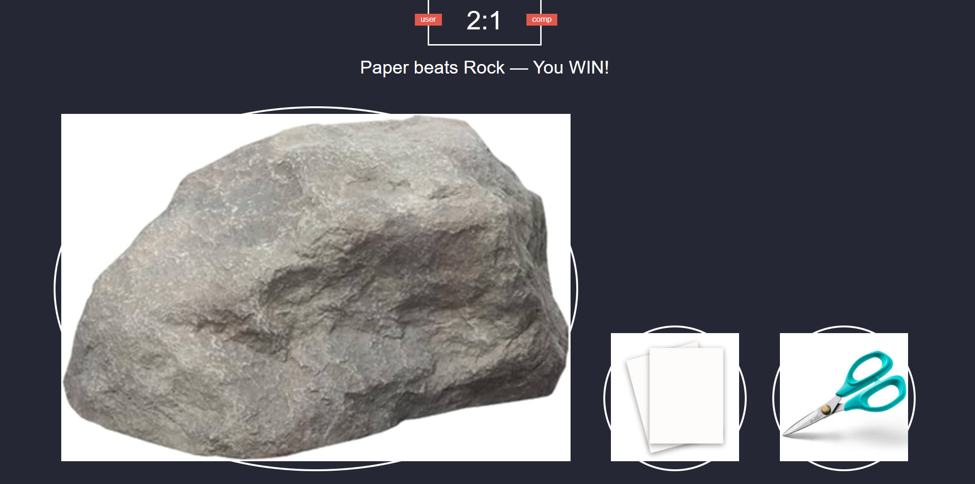
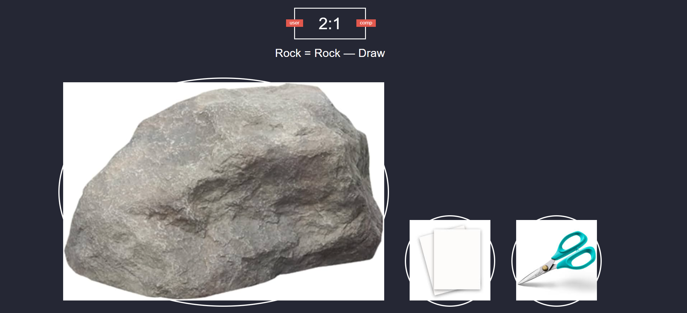
This is exactly how it works

